GROW FRAMEWORK SHEET

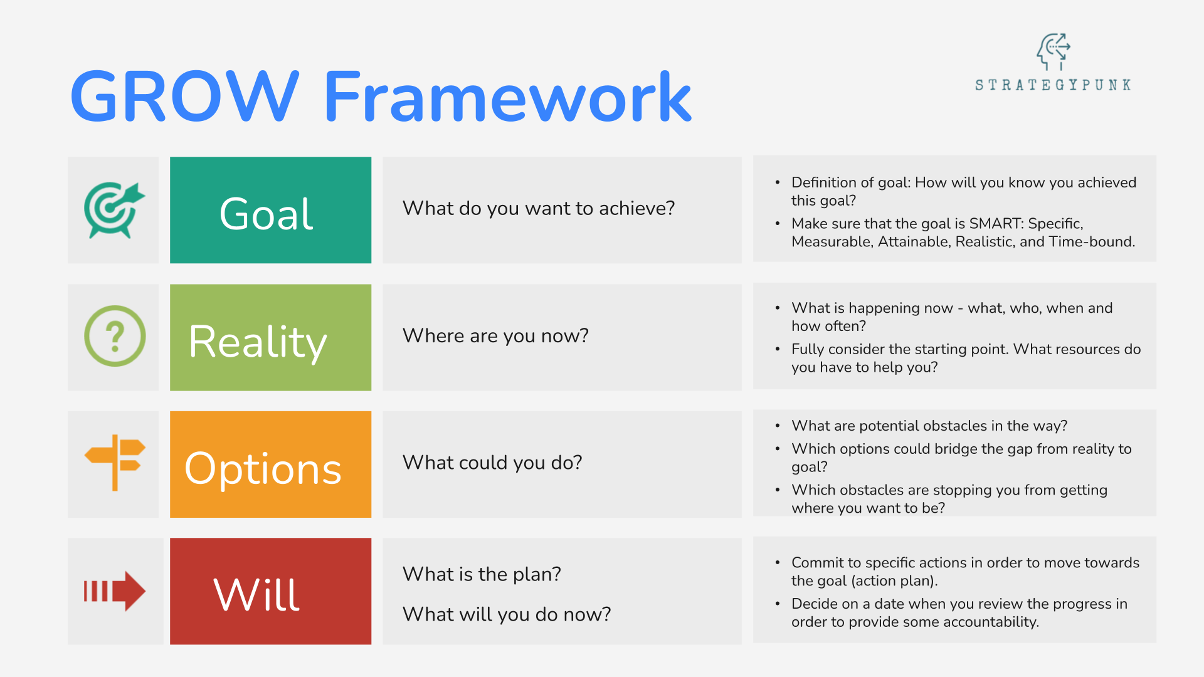

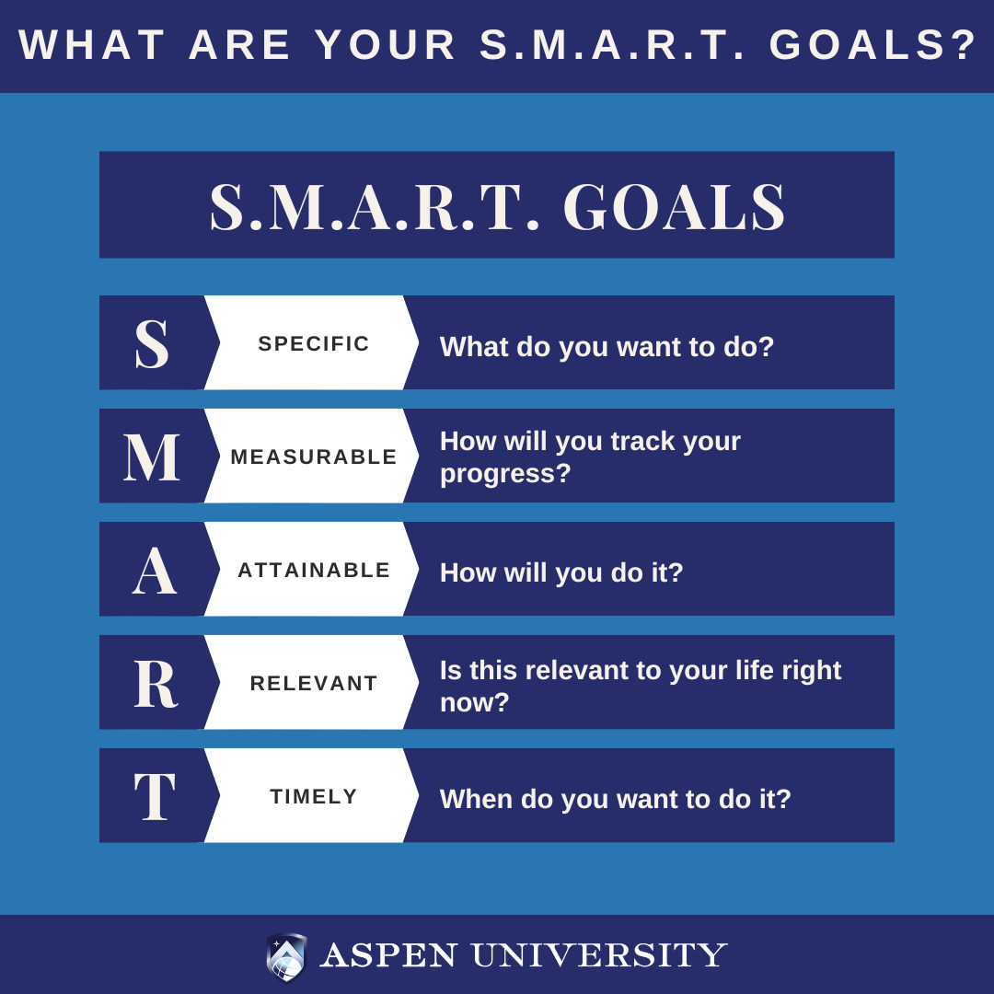

**GROW FRAMEWORK SHEET**

| **Goal**  What do you want to accomplish?    How will you know when it is achieved? |  |
| --- | --- |
| **Reality**  What’s happening now in terms of the goal?    How far am I away from the goal? |  |
| **Options**  What options do I have to resolve the issues or obstacles? |  |
| **Way Forward/Will**  Which option will I commit to? |  |